**SPRINT 4 PLANNING**



**Author: Imagineers Team**

**Date: 05/04/2017**

**Revision history**

|  |  |  |  |
| --- | --- | --- | --- |
| **Version** | **Date** | **Author** | **Notes** |
| 1.0 | 05/04/2017 | Thạch Nguyễn | Create document |
|  |  |  |  |

Contents

I. INTRODUCTION 4

1. Purpose 4

2. Audience 4

II. SPRINT 4 GOALS 4

III. SPRINT 4 BACKLOG 4

IV. SPRINT 4 TASK 5

V. SPRINT 4 DEFINTION OF DONE 8

# INTRODUCTION

## Purpose

This document describes how sprint 4 is planning. The plan describes in simple, straight forward term the processes required to ensure that the sprint 4 stories re estimated and ensures the goals of sprint 4.

## Audience

This document is created for Scrum team .

# SPRINT 4 GOALS

* This is the first sprint execution so the priority of the product as customer wishes is to have the profile of the member. Because every swap activities will base on the profile
* The next goal is finishing the sprint 4 selected stories with full artifacts that is defined in the “definition of done”
* Finishing the sprint 2 on time. With all the stories that was chosen to put in sprint 4
  + User sign in via Facebook
  + User view About us Page
  + User view Contact Us
  + User view FAQs
  + User view detail of other user
  + User Search skills
  + Member View request log page
  + Member Request swap
  + Member Exchange swap detail

# SPRINT 4 BACKLOG

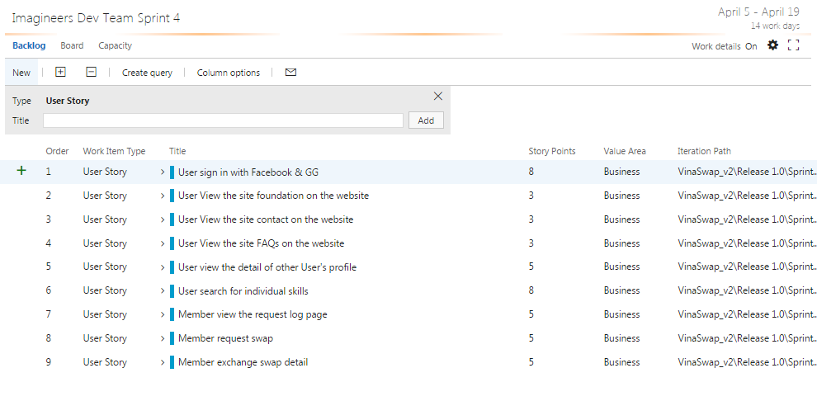

# SPRINT 4 TASK

|  |  |  |  |  |  |
| --- | --- | --- | --- | --- | --- |
| User story | Task | Assigned | Estimation (hrs) | Actual  (hrs) | Status |
| User sign in with Facebook | Design UI | Phuong Nguyen | 4 |  |  |
|  | Write unit test – sign in with Facebook server side | Tai Nguyen | 2 |  |  |
|  | Run unit test – sign in with Facebook server side | Tai Nguyen | 2 |  |  |
|  | Write Unit test – sign in with Facebook client side | Tai Nguyen | 2 |  |  |
|  | Run Unit test – sign in with Facebook client side | Tai Nguyen | 2 |  |  |
|  | Code HTML/CSS – sign in with Facebook | Quang Nguyen | 4 |  |  |
|  | Code client side– sign in with Facebook | Quang Nguyen | 6 |  |  |
|  | Review code | Chanh Tran | 2 |  |  |
|  | Run functional test case- sign in with Facebook | Viet Dang | 2 |  |  |
|  | Write acceptance test – sign in with Facebook | Phuong Nguyen | 1 |  |  |
|  | Write test report – sign in with Facebook | Viet Dang | 2 |  |  |
|  | Build Deploy | Thach Nguyen | 2 |  |  |
|  |  |  |  |  |  |
| User View the site foundation on the website | Design UI | Phuong Nguyen | 4 |  |  |
|  | Run functional test | Viet Dang | 1 |  |  |
|  | Code HTML/CSS | Viet Dang | 6 |  |  |
|  | Write Use Case – Foundation | Phuong Nguyen | 1 |  |  |
|  |  |  |  |  |  |
| User View the site contact on the website | Design UI | Phuong Nguyen | 4 |  |  |
|  | Run functional test | Viet Dang | 1 |  |  |
|  | Code HTML/CSS | Viet Dang | 4 |  |  |
|  | Write Use Case – site contact | Phuong Nguyen | 1 |  |  |
|  |  |  |  |  |  |
| User View the site FAQs on the website | Design UI | Phuong Nguyen | 4 |  |  |
|  | Run functional test | Viet Dang | 2 |  |  |
|  | Code HTML/CSS | Viet Dang | 6 |  |  |
|  | Write Use Case – FAQs | Phuong Nguyen | 1 |  |  |
|  |  |  |  |  |  |
| User view the detail of other User's profile | Design UI | Phuong Nguyen | 2 |  |  |
|  | Write unit test –server side | Tai Nguyen | 4 |  |  |
|  | Run unit test –server side | Tai Nguyen | 4 |  |  |
|  | Write Unit test –client side | Tai Nguyen | 4 |  |  |
|  | Run Unit test –client side | Tai Nguyen | 4 |  |  |
|  | Code HTML/CSS | Quang Nguyen | 6 |  |  |
|  | Code client side– detail of other User's profile | Quang Nguyen | 10 |  |  |
|  | Run functional test case | Viet Dang | 4 |  |  |
|  | Write acceptance test | Phuong Nguyen | 1 |  |  |
|  | Write test report | Viet Dang | 2 |  |  |
|  | Build Deploy | Thach Nguyen | 2 |  |  |
|  |  |  |  |  |  |
| User search for individual skills | Code server side – search skills | Chanh Tran | 8 |  |  |
|  | Code client side – search skills | Quang Nguyen | 16 |  |  |
|  | Design Darabase | Thach Nguyen | 6 |  |  |
|  | Code HTML/CSS | Quang Nguyen | 8 |  |  |
|  | Write unit test – client side | Tai Nguyen | 2 |  |  |
|  | Run unit test – client side | Tai Nguyen | 4 |  |  |
|  | Write User case – search skills | Phuong Nguyen | 2 |  |  |
|  | Build deploy product environment | Thach Nguyen | 4 |  |  |
|  | Write functional test | Viet Dang | 4 |  |  |
|  | Run functional test | Viet Dang | 2 |  |  |
| Member view the request log page | Design UI | Phuong Nguyen | 8 |  |  |
|  | Code HTML/CSS | Viet Dang | 10 |  |  |
|  | Code server side | Chanh Tran | 10 |  |  |
|  | Write functional test – request log page | Viet Dang | 8 |  |  |
|  | Run functional test – request log page | Viet Dang | 4 |  |  |
|  | Write acceptance test | Phuong Nguyen | 5 |  |  |
|  | Write Unit test – request log page client side | Tai Nguyen | 4 |  |  |
|  | Run unit test – request log page client side | Tai Nguyen | 4 |  |  |
|  | Write Unit test – request log page server side | Tai Nguyen | 4 |  |  |
|  | Run unit test – request log page server side | Tai Nguyen | 4 |  |  |
|  | Write Use case – request log page | Phuong Nguyen | 2 |  |  |
|  |  |  |  |  |  |
| Member request swap | Design UI | Phuong Nguyen | 8 |  |  |
|  | Code HTML/CSS | Viet Dang | 8 |  |  |
|  | Code client side – request swap | Quang Nguyen | 8 |  |  |
|  | Code server side – request swap | Chanh Tran | 8 |  |  |
|  | Write unit test – request swap client side | Tai Nguyen | 4 |  |  |
|  | Run unit test – request swap client side | Tai Nguyen | 4 |  |  |
|  | Write unit test – request swap server side | Tai Nguyen | 4 |  |  |
|  | Run unit test – request swap server side | Tai Nguyen | 4 |  |  |
|  | Write use case - request swap | Phuong Nguyen | 2 |  |  |
|  | Run functional test – request swap | Viet Dang | 2 |  |  |
|  | Write functional test | Viet Dang | 4 |  |  |
|  |  |  |  |  |  |
| Member exchange swap detail | Design UI | Phương Nguyen | 8 |  |  |
|  | Code HTML/CSS | Quang Nguyen | 4 |  |  |
|  | Code client side – exchange swap detail | Quang Nguyen | 8 |  |  |
|  | Code server side – exchange swap detail | Chanh Tran | 8 |  |  |
|  | Write unit test – exchange swap detail client side | Tai Nguyen | 4 |  |  |
|  | Run unit test – exchange swap detail client side | Tai Nguyen | 4 |  |  |
|  | Write unit test – exchange swap detail server side | Tai Nguyen | 4 |  |  |
|  | Run unit test - exchange swap detail server side | Tai Nguyen | 4 |  |  |
|  | Write Use case – exchange swap | Phuong Nguyen | 5 |  |  |
|  | Run functional test | Viet Dang |  |  |  |
|  | Build deploy | Thach Nguyen |  |  |  |
| Re test Edit my page/Edit about me/Create profile | Run unit test | Tai Nguyen | 2 |  |  |
|  | Code server side | Chanh Tran | 4 |  |  |
|  | Code client side | Quang Nguyen | 4 |  |  |

# SPRINT 4 DEFINTION OF DONE

|  |  |  |
| --- | --- | --- |
| Category | Detail | Artifacts |
| User Story Clarity | User stories selected for the sprint are complete with respect to product theme, understood by the team, and have been validated by the detailed acceptance criteria. | Product backlog/ User story |
| Tasks Identified | Tasks for selected user stories have been identified and estimated by the team. - |  |
| Product owner approval | Each finished user story has been passed through UAT (User Acceptance Testing) and signed off as meeting requirements | References : Acceptance test |
| Updating Product Backlog | All features not done during the sprint are added back to the product backlog. All incidents/defects not handled during the sprint are added to the product backlog. | Imagineers-Productbacklog |
| Environment ready | Development environment is ready with all third-party tools configured.  Staging environment is ready.  Continuous integration framework is in place  Test data for the selected features has been created | Task management : Team service  Coding: Visual code  Document: Microsoft Office |
| Design complete | Design analysis is complete as per the user story or theme.  Prototype have been created and approved by the respective stakeholders.  Use cases are developed | Imagineers-Usecase  Imagineers-Prototype |
| Unit test cases written | Unit test cases have been written for the features to be developed |  |
| Documentation Ready | Documentation to support the sprint demo is ready |  |
| Code Complete | Source code changes are done for all the features in the “to do” list.” Source code has been commented appropriately. |  |
| Unit testing is done | Unit test cases have been executed and are working successfully |  |
| Code Refactoring | Source code has been refactored to make it comprehensive, maintainable and, amenable to change. |  |
| Code checkin | Source code is checked in the code library with appropriate comments added. |  |
| Code merging and tagging | Finalized source code has been merged with the main branch and tagged appropriately (merging and tagging guidelines are to be used) |  |
| Project metrics are ready | Burndown chart has been updated regularly and is up to date. |  |
| Functional testing done | Test team has reviewed and conducted necessary manual test cases to ensure that tests are passing. All incidents/defects are reported.  100% executed test cases and 80% test cases pass.  There are no major defect occurred  Accept 20% minor defects in layout or the defect doesn’t affect system | Imagineers-TestCase  Imagineers-TestReport |
| Acceptance testing done | Each finished user story has been passed through UAT (User Acceptance Testing) and signed off as meeting requirements (see also Product Owner Approval). | Imagineers-AcceptanceTest |
| Closure | All finished user stories/tasks are marked complete/resolved. Remaining hours for task set to zero before closing the task. |  |